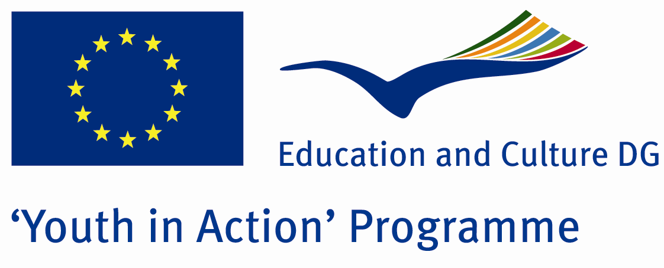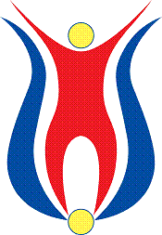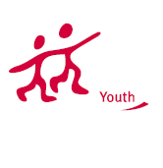

Diabled Mins

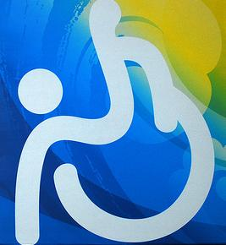

ACTION 1.1 – Youth Exchange

01-08th July, 2012

Sakarya, TURKEY

ACTION 1.1 Youth Exchange
01-08th July, 2012
Sakarya, TURKEY

Please contact directly to:
groupserapis@gmail.com
Project Summary; The theme of this project is disabled people. In the society, there is not enough understanding for the disabled people. Everybody says that they support the rights of disabled people, but in the daily life they ignore the disabled people. Don’t care for their problems, don’t try to understand how different problems they would have and do almost nothing for them. The people generally realise this problem exactly when they are disabled or the people they know. With this project, we will take interest of more young people and the society, discuss and understand more about the problems of disabled people and ignorance of society. So if you find this theme important, we need your partnership!

Project Title; There is no obstacle, but society

Date and Venue ; 01-08th July , 2012 Sakarya, Turkey .

Target Group ; Municipalities, City Councils and Non-Governmental organizations,
youth groups,culture and art groups,e.t.c

Participants ; 5 people from each country (over 18 -25 ). Totally 8 countries.

Conditions ; Accommodation, board and programme costs will be financed through European Commission Youth in Action Programme (Action 1.1). Travel costs will be reimbursed in 70% (APEX Tarrifs). Organizations from all 27 EU member countries plus Liechtenstein , Norway and Iceland are eligible to take part.

Working language: English

Organizer:Group Serapis

How to apply: If you are interested, please send your Part III forms to
by e-mail please (in word file). Scan Part3 format is enough for application.(Fulfilled Part III which you can find in the attachment, of course signed and stamped) ..

If you have any questions you may contact with:
groupserapis@gmail.com

Deadline for application; until 10 October 2011.

